TRANSPORT COMPONENT TEST CASES

|  |  |  |  |
| --- | --- | --- | --- |
| **INPUT** | **Expected o/p** | **STATUS** | **BUG/ERROR** |
| *726*1#/*726*115# | When you put the code it takes you to the screen which give you option to choose the language.  1.KINYARWANDA  2.ENGLISH  3.FRANCAIS | SUCCESS |  |
| Input Number for selecting Language | After you give input for choose the language it take to the screen for selecting departure.  Departure: | SUCCESS |  |
| Input Departure Place Name | After we give the input for departure place name it takes us to a screen.  Select Departure.  1.KIGALI  2.BACK | SUCCESS |  |
| Input The No For Selecting Departure | After we give the input it take us to a screen to  Search destination  From: KIGALI  Enter Destination | SUCCESS |  |
| Input Destination Place Name | After we give the input of the destination place name it take us to a screen.  Choose destination.  From: KIGALI  select Destination.  1.MUHANGA  2.BACK | SUCCESS | If you place same destination as Departure The system still gives you the option to continue choose the time period. |
| Input The Number For Selecting Destination | After we give the input for selecting destination it takes us to a screen to Choose Departure day.  Select Departure Day  1.Today  2.Tomorrow | SUCCESS | When we give the input for TOMORROW and we select the time period in next screen it don’t show us the specific time list. |
| Input The Number For Selecting Departure Day | After we give the input of selecting departure day it takes us to a screen  Choose Time Period.  From:KIGALI  To:MUHANGA  Date:2015-10-16  Select Period  1.Between 5h and 8h  2.Between 9h and 12h  3.Between 13h and 16h  4.Between 17h and 20h | SUCCESS |  |
| Input The Number For Selecting Period | After we give the input of selecting period it takes us to a screen to Select Specific Time  Select Time:  1.17H  2.18H  3.19H  4.20H  5.Back | SUCCESS |  |
| Input The Number For Selecting Time | After we give the input for selecting time it takes us to a screen to Select Transporter  Select Transporter:  1. Capital Express: 850RWF  2.Back | SUCCESS |  |
| Input The Number For Select The Transporter | After we give the input For Select The Transporter it takes us to a screen to Select Promotions  Promotions:  1.Use Promotion Code  2.Register for Promotion  3.Not interested In promotion  4.Back | SUCCESS | If with booked a ticket for tomorrow and select the use of promotional code, the Mobile Money Account doesn’t get credited/ in Mobile money we don’t get any pending approval for ticket purchase. |
| Input The Number For The Promotions | After we give the input For Select The Promotions it take us to a screen to Provide The Number  Type Existing Code  07XXXXXXX | SUCCESS |  |
| Input The Mobile Number | After we give the input As Mobile No it take us to a screen to  Promo Given to Aubain(Phone Number Owner)  1.Purchase the ticket  2.Change code | SUCCESS |  |
| After We Give Input to Buy Ticket | It take Us Mobile money Approval Screen  A payment request of 850 Rwf is sent to your mobile money. | SUCCESS |  |

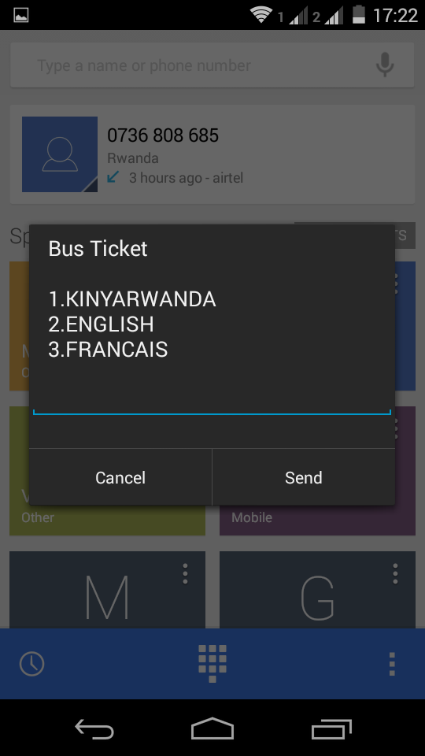

**Home Screen**

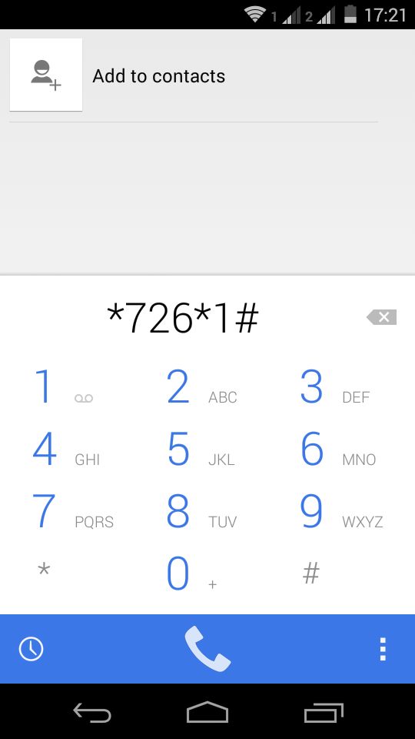

**Starting Screen**

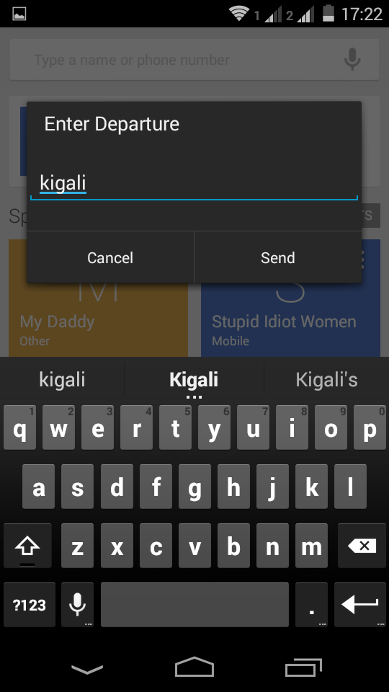

**Departure Selection**

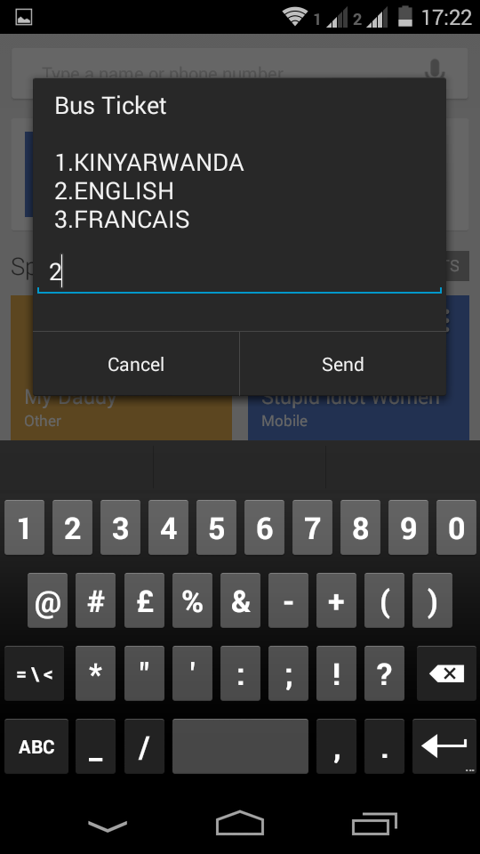

**Language Selection**

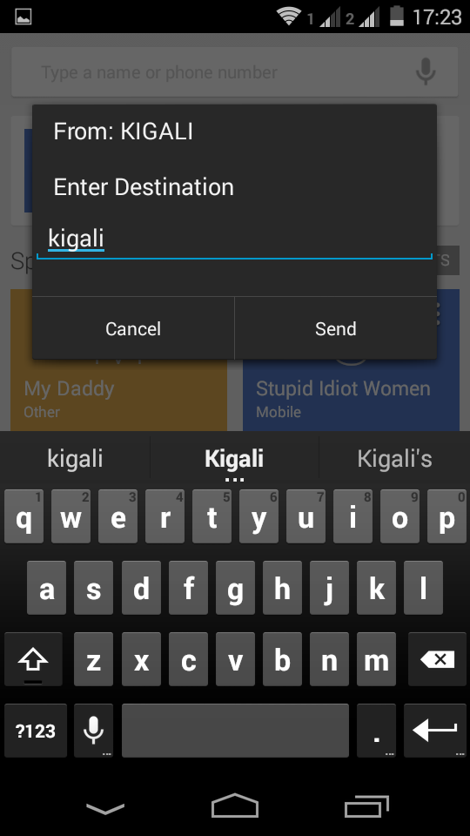

**Destination**

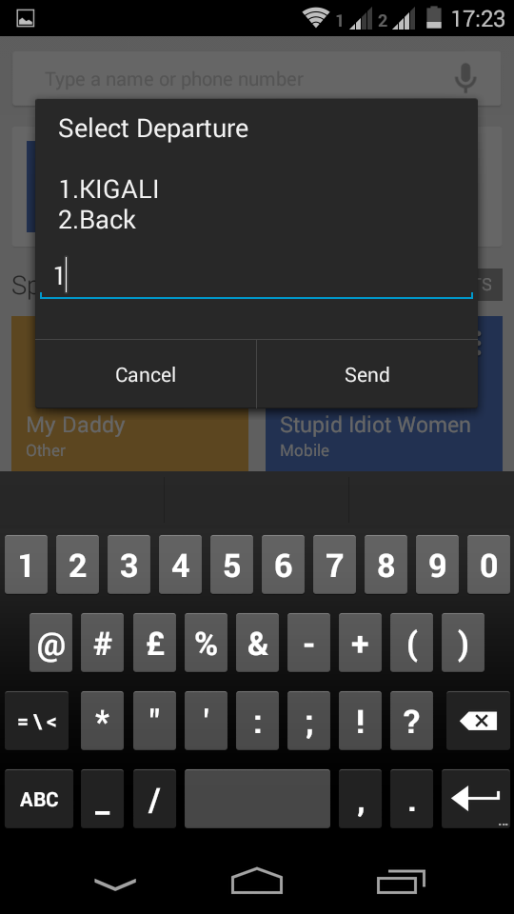

**Departure**

**Confirmation**

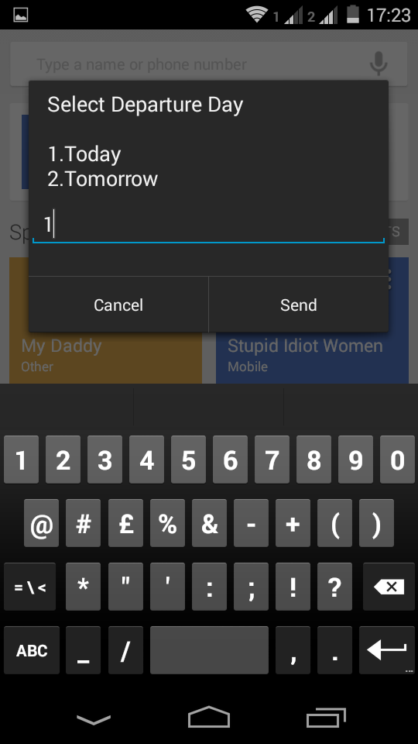

**Time Selection**

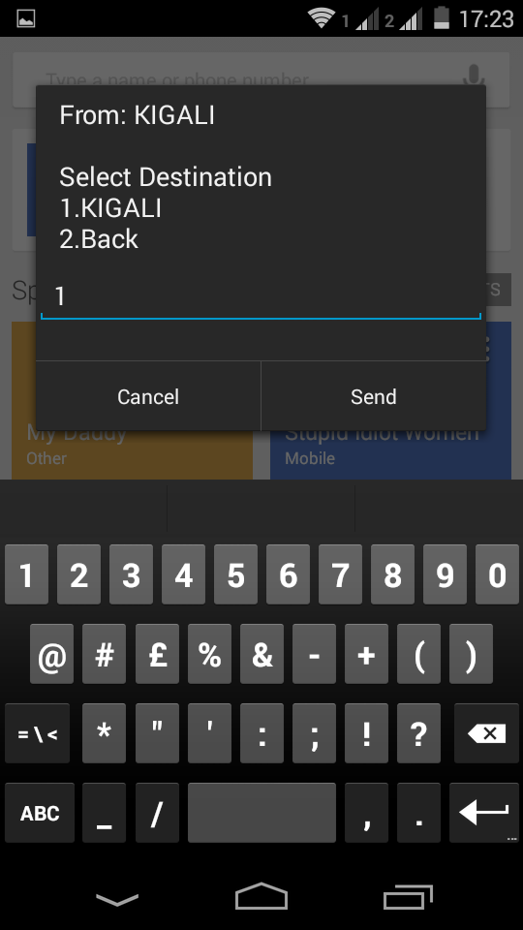

**Destination**

**Confirmation**

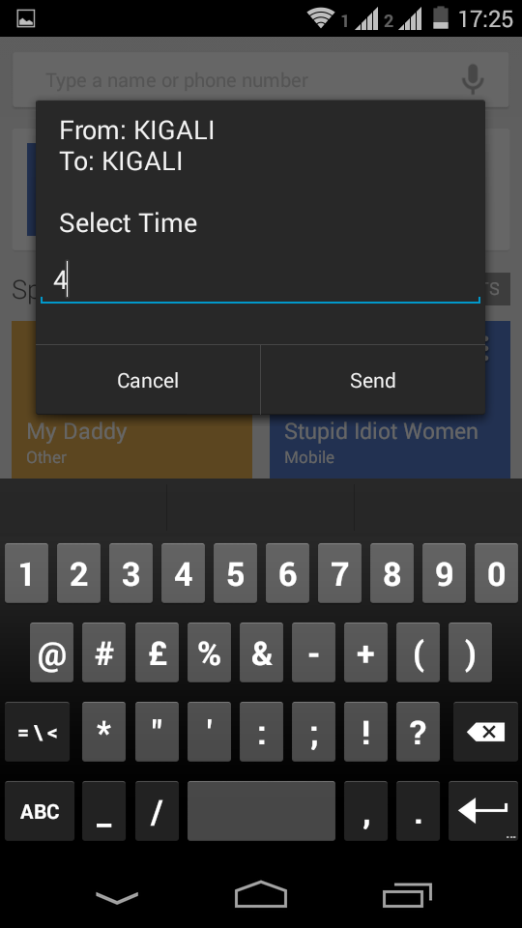

**Any Value taken into Time box**

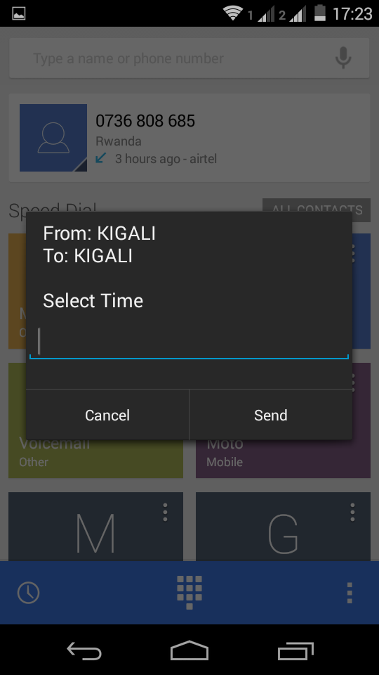

**No List to select time**

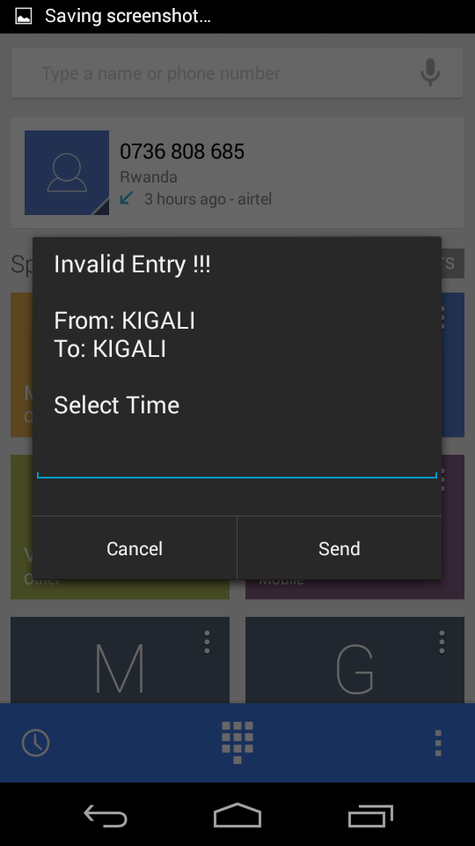

**Invalid Message is returned**

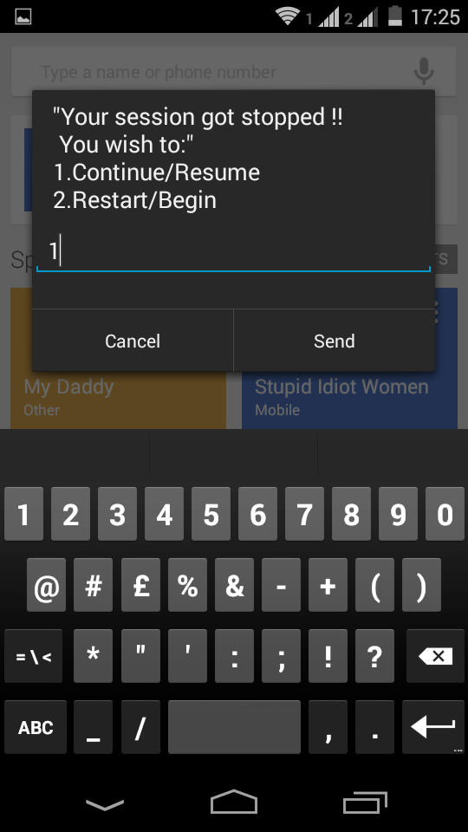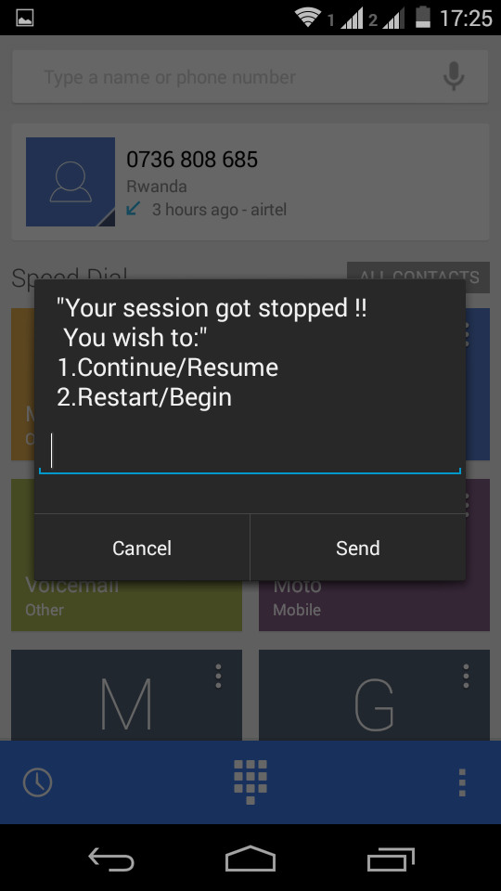

**Session resuming after time list failed**

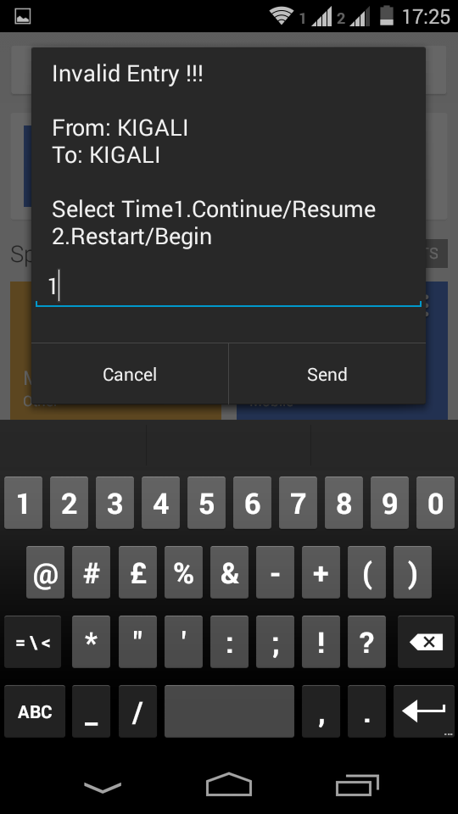

**Continue here is not working**

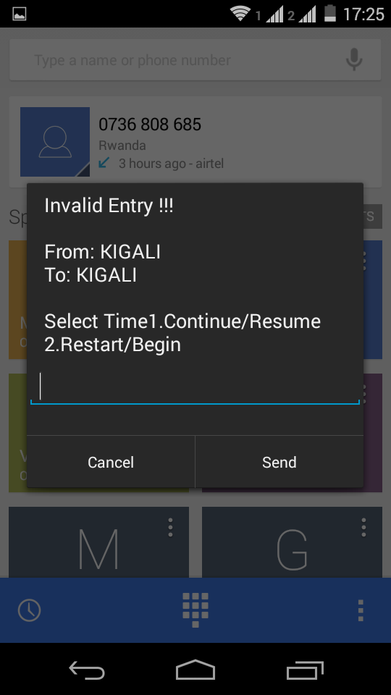

**Return to the error message**

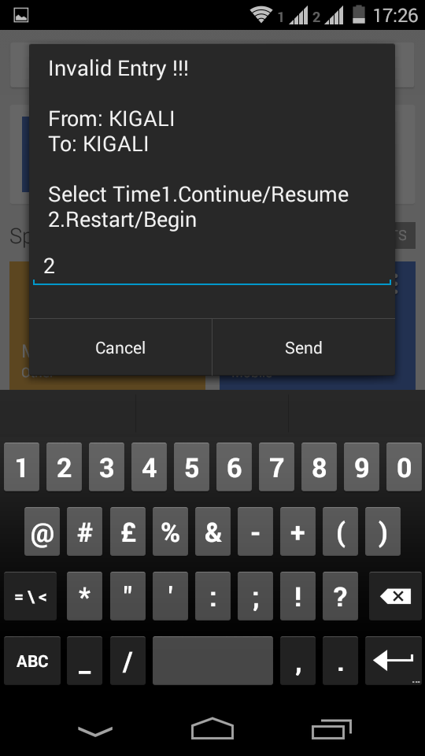

**Get back to home page is not responding**

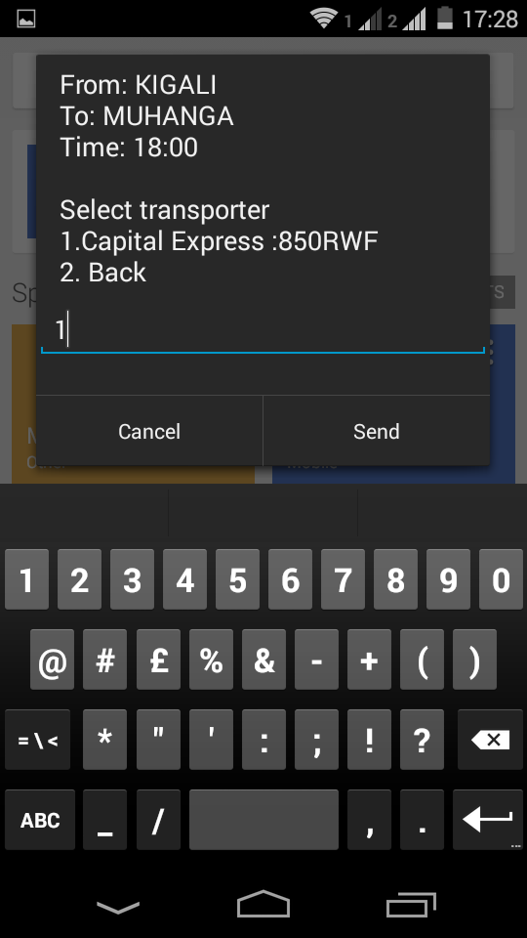

**Transport**

**Company selection**

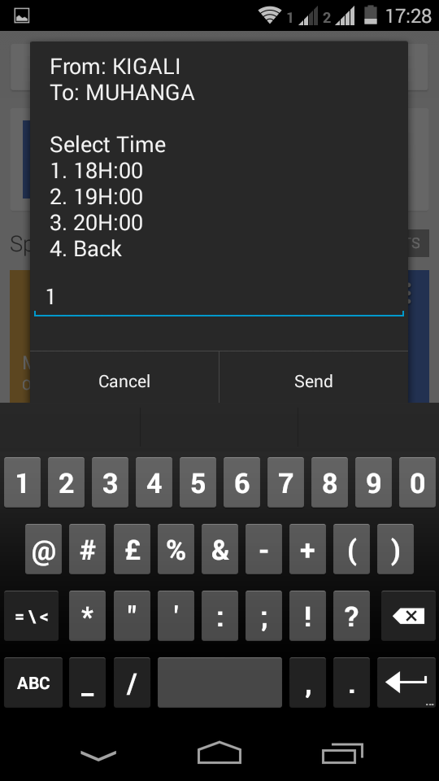

**Time selection**

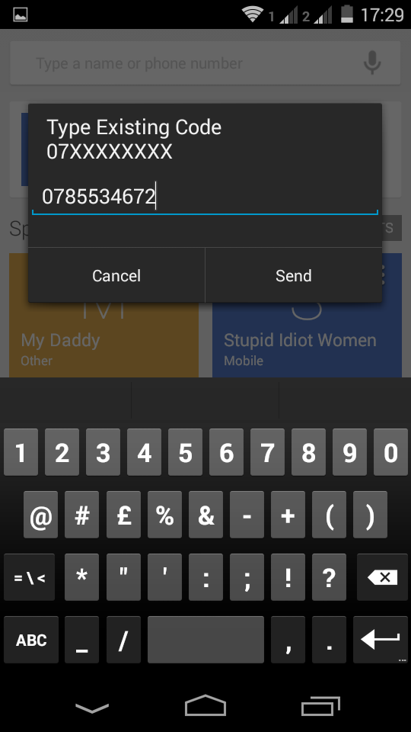

**Code capture**

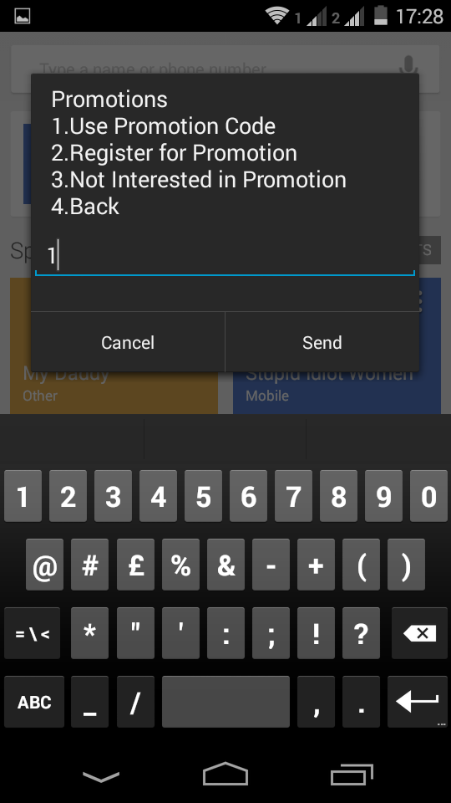

**We Use a**

**Promotional code**

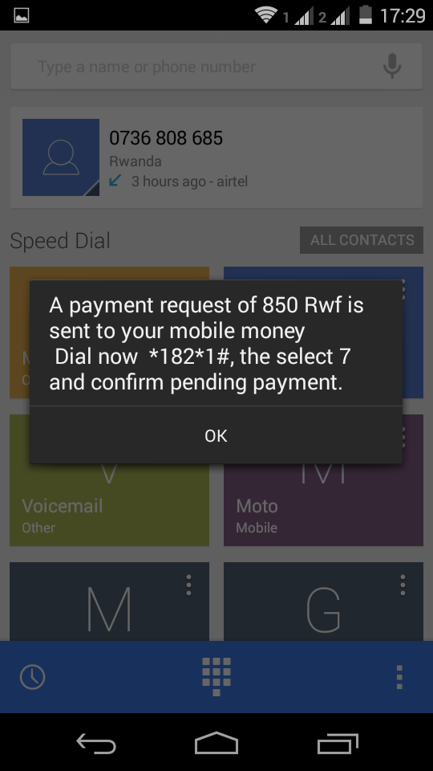

**Ticket Approval**

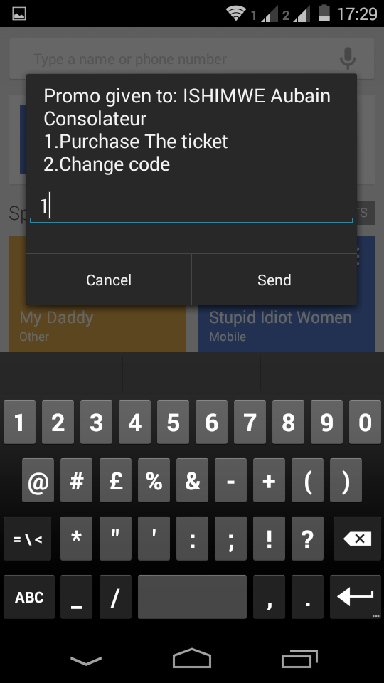

**Code Validation and ticket**

**Purchase**

**MTN Mobile Money**

**Pending approval is empty**

